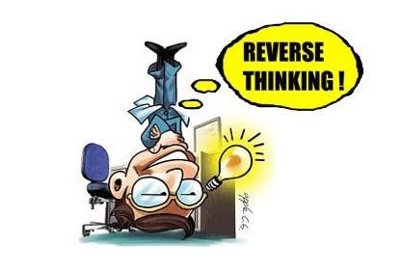
A creative way to look at a problem differently.

Reverse thinking is a brainstorming technique that challenges our thinking on how to approach a problem. Instead of coming up with ideas of how to solve a problem, solve by identifying how to cause the problem. When approaching the brainstorming session as a group, there are five critical steps, which include:

- Openly establish the problem to be solved by the group and write it down.
- Reverse the problem by coming up with ideas on how to contribute to or cause the problem.
- Brainstorm how to solve the reversed problem and write down all thoughts.
- Once the group has identified how to make the problem worse, then reverse those ideas to find solutions on how to eliminate the original challenge or problem.
- Analyze the results and determine the best approach.

Reverse thinking at work:

- Problem statement identified is “How to effectively de-escalate a difficult conversation with frustrated customers.”
- The problem statement reversed could be “How to make customers more frustrated.”
- Brainstorming the reverse problem could generate ideas such as:
- Put the customer on hold while they are expressing concerns.
- Don’t listen to their concerns.
- Show no empathy.
- After the brainstorming session has been exhausted of ideas, it is time to reflect and reverse the ideas. Looking at the list of solutions to the reversed problem tends to quickly make it clear how effective solutions can be put in place to address the original issue. Clearly showing no empathy or not listening are not positive solutions.
- Reviewing ideas of how to solve the reversed problem reveals ways to address the original problem. It becomes clear what to avoid, providing ways to eliminate the original problem.

Reverse thinking is a great way to empower the group and provide a fun, enlightening, and open environment to express ideas freely.

References

Mind Tools. (n.d.). Reverse brainstorming A different approach to brainstorming.
Retrieved from
https://www.mindtools.com/pages/article/newCT_96.htm

https://www.flickr.com/photos/65748848@N07/6404402205

